API Documents for Hackathon

|  |  |  |  |
| --- | --- | --- | --- |
| API Name | URL | Method Type | Input Parameter |
| Text to Speech | /api/v1/text/speech | POST | uid - required |
|  |  |  | language - optional default value 'en' |
|  |  |  | text - required |
|  |  |  |  |
| Speech to Text | /api/v1/speech/text | POST | uid - required |
|  |  |  | pronounciation - required |
|  |  |  |  |
| Get Speech | /api/v1/fetch/speech | POST | uid - required |
|  |  |  |  |
| Update Speech | /api/v1/update/speech | POST | uid - required |
|  |  |  | pronounciation - required |
|  |  |  |  |

Call text to speech API in postman –

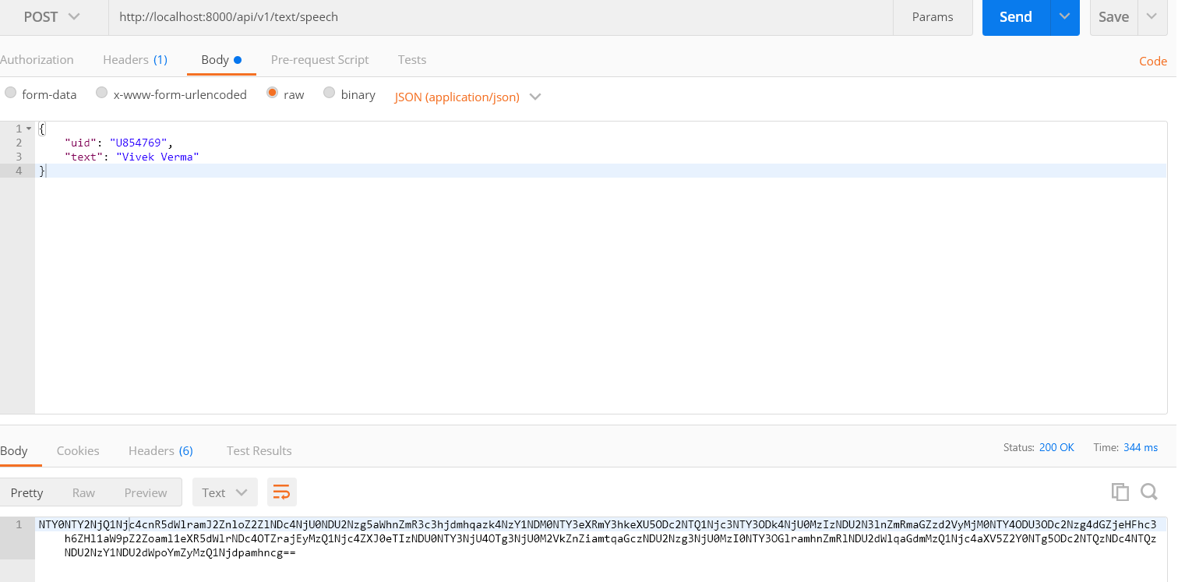

Call speech to text API in postman –

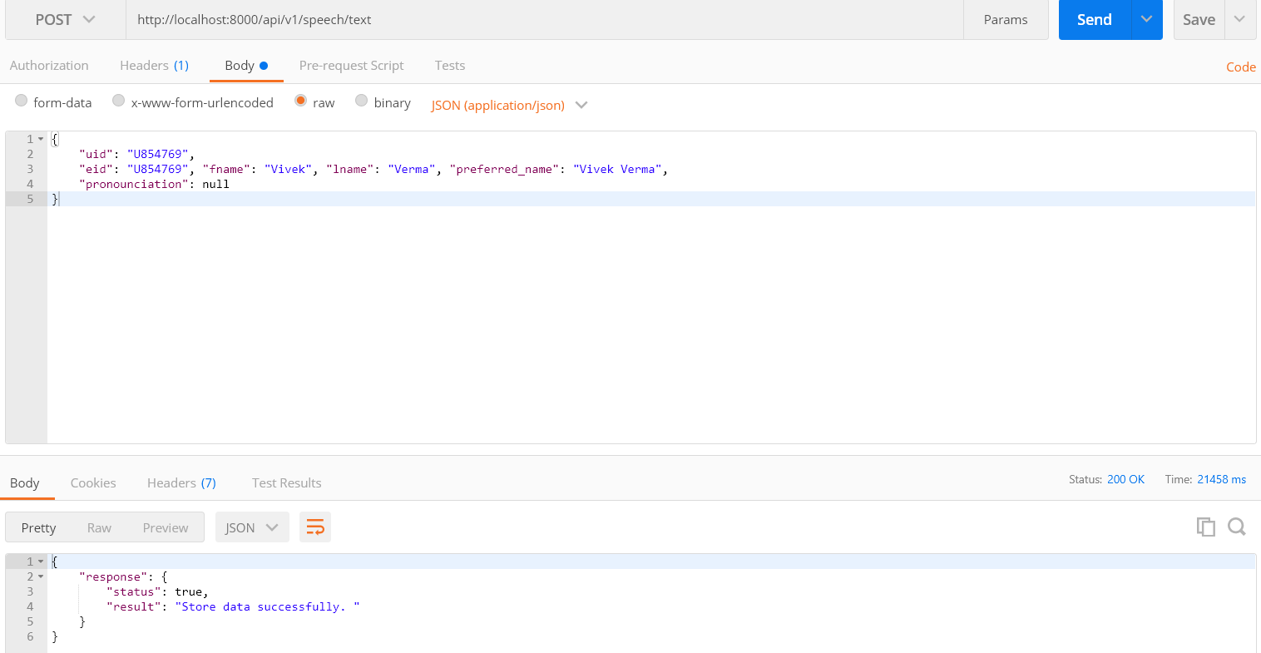

Call get speech to text API in postman –

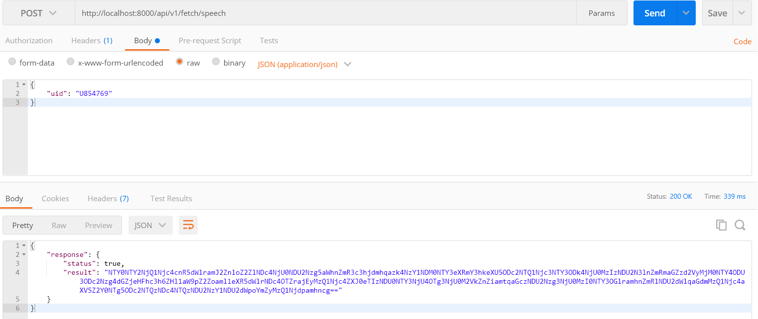

Call update speech to text API in postman –

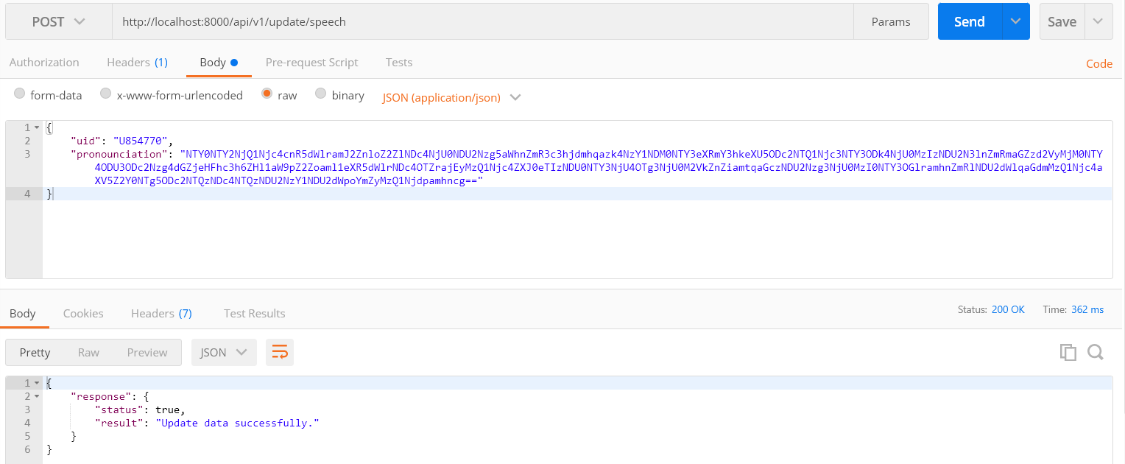

How to connect **Yugabyte** database

Import psycopg2 in python client library to connect yugabyte database. See below code snippet –

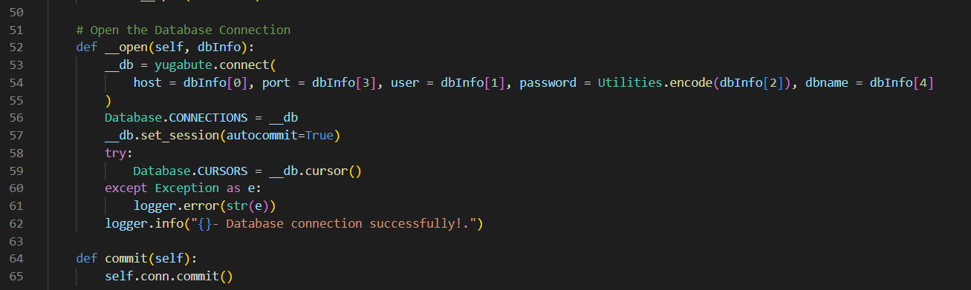

Note – Attached the code as well

